**Practical 6**

**AIM :** Experiment to study Date functions and Mathematical functions supported by Oracle.

**Shashwat V. Tripathi D10A Roll No: 60**

**Date Functions:**

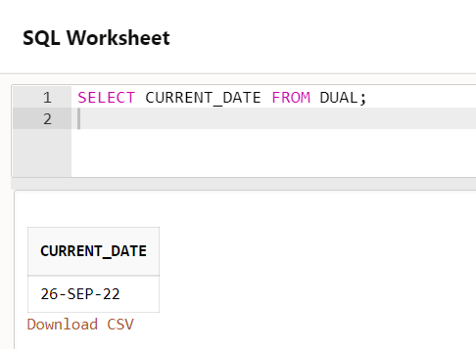

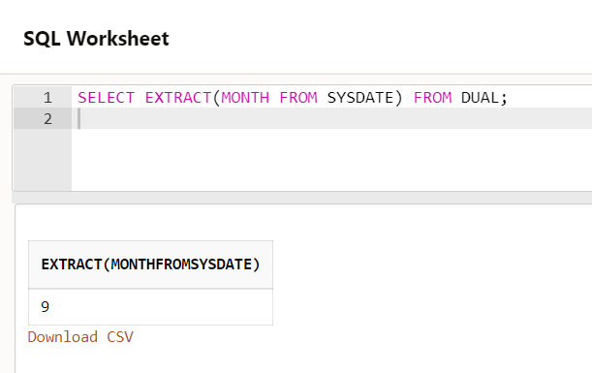

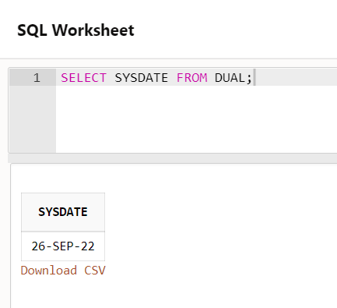

**Mathematical Functions:**



